**An Appropiate Way to Design Good User Interface**

Nowadays we are all using electronics devices to handle our daily activities. All theses electroinics devices comes with a control panel or dashboard user interfaces. As a human, we seldom deal with the hardware directly, we usaully deal with an user interface, an user interface is a graphical user interface with screens, buttons, selection boxes...etc, each user interface handles specific tasks. How to design the user interface is base on what tasks you are handling. A good user interface allows users to handle the task efficiently and also without too much learning effort in using it. One may ask, is there any good way to design a good user interface? Probabily, not the best but an appropiate way. The first thing we need to ask what is an user interface? As said before an user interface allows user to handle specific tasks, an user interface is a combination of fields and selection boxes, usually comes with a button to commit changes. Fields? yes! fields holds data and through the user interface to deal directly with a dataware house (such as databases, files...etc). Dataware house or database seems a way to design good user interface. As we all know a database is collection of entities (tables for short) which have relationship with each other and bind with constraints on how to store the data. Therfore I might answer you, how your interface looks, is base on what entities or tables you are dealing with. For short, a **user interface** is a database **entity (table).** Let takes an example.

I once enconter an app and found it very difficult to handle a very simple task. This is payment app, I just want to handle a very simple task. This task is to **check** my transaction records.

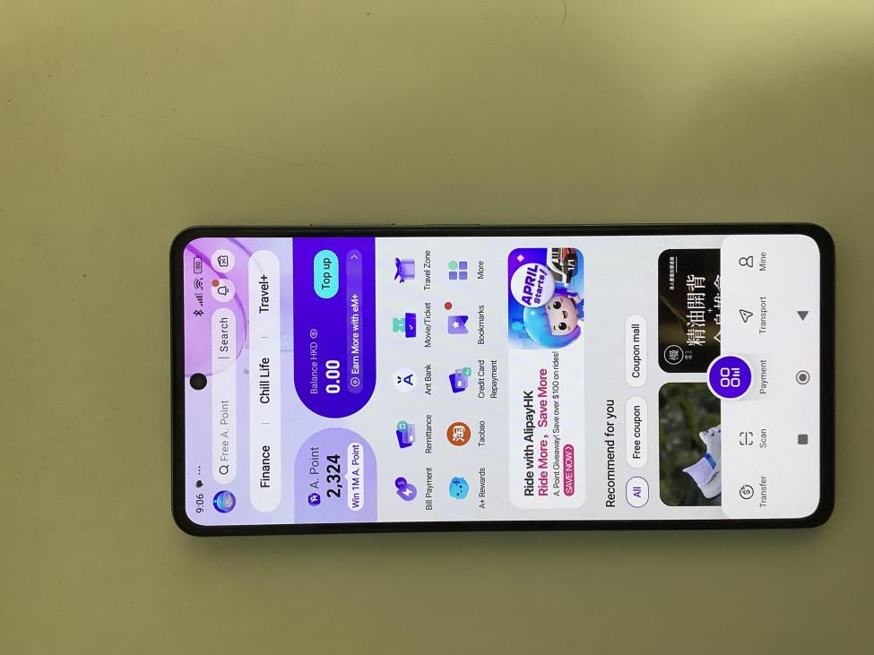

The above is the main interface, but through this interface, I have no idea where to find a way to check my transaction records? Wield! isn’t it? But at last I found it. Where? it is from the top up user interface page.

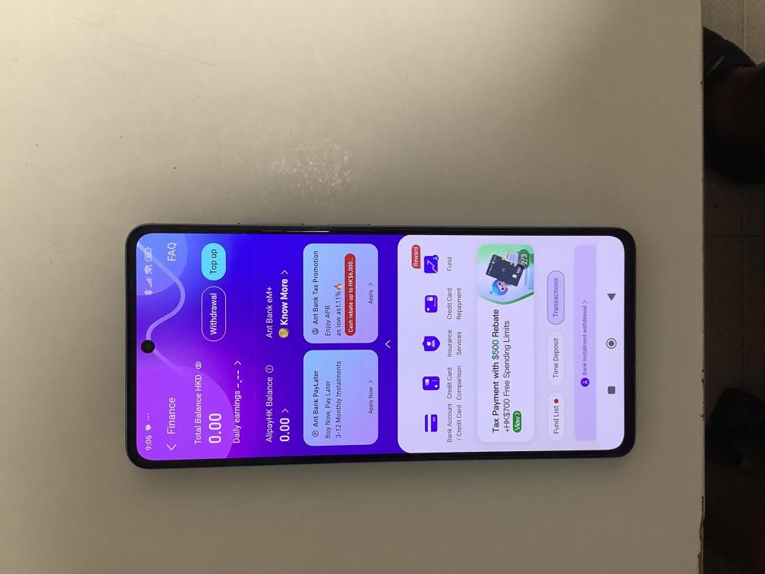

As discussed before how your user interface looks is base on what table or entity you are dealing with. I assume the all the transaction records are stored in a table maybe call “Trasaction_Records” and also there will be a table call maybe “Personal_Account” to store the user’s money. Let see how the Entity Relationship Diagram (ER Diagram) will be looks like.

**ER Diagram**

Trasactin _Records

User

HKID

HKID

One to Many

Trasaction Date

Name

Amount

One to One

Personal_Account

HKID

Amount

This is just a make up of the ER diagram, but if I am sure that the transaction history records are stored on a seperate table which does not have any relationship with to “Personal_Account” (Top Up User Interface) table. Then why the trasaction history records needs to be in the “Top Up User Interface” page? Is there any Primary key links from the “Personal_Account” table to the “Trasction_Records” table? Why just not put the “Trasaction_Records” to the main user page? Which allows user to be found efficeintly and easily be accessed.